Biodiversity Mapping
Louis from the National Education Nature Park visited St Clare’s to help create a biodiversity map of the school grounds. Some of our nature enthusiasts from LKS2 learned how to categorise different areas and identify the types of wildlife that would benefit from them. It was a fantastic opportunity to explore how our school grounds can support local wildlife.
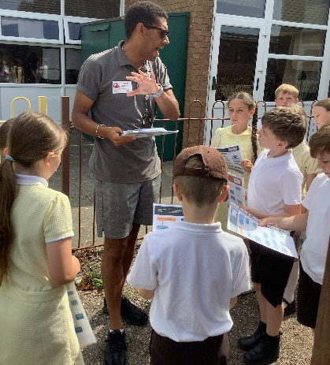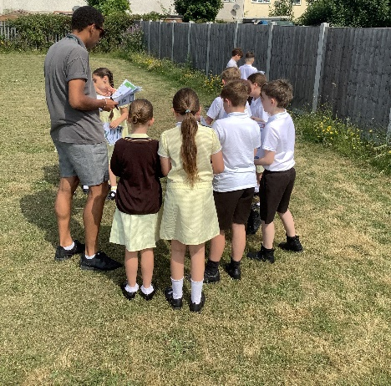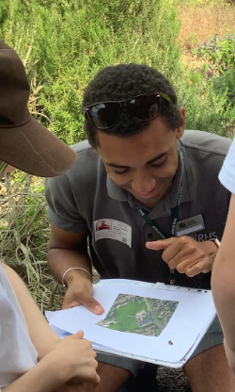
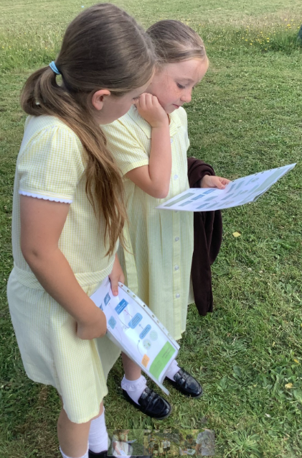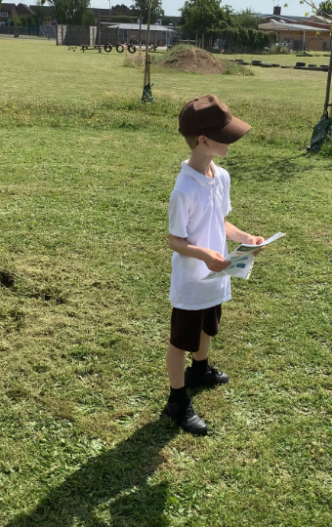
We identified:
“We learned about all the habitats and we also learned about all the different plants and how they grow!”
Summer – Y4
- Wildlife hedges
- Meadow
- Tall wild plants
- Bug hotel
- Wildlife patch
- Broadland woodland
- orchard

