St Clare’s Library
At St Clare’s, we are lucky enough to have a fantastic library. There is a wonderful selection of books with something for everyone!
Meet our Librarian Miss Aggie
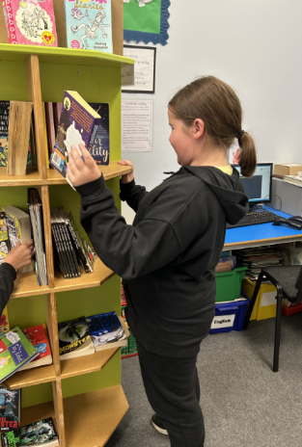
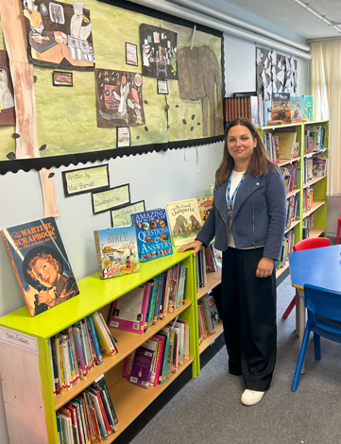 Meet two of our School Librarians
Miss Aggie works tirelessly to keep our library well stocked, organised and tidy. She reminds the children when books are overdue too, so if you have any library books at home, please do send them back so that we are always fully stocked!
Charlotte and Phoebe are two of our fabulous school librarians. Miss Aggie has been training them to help keep our library running smoothly.
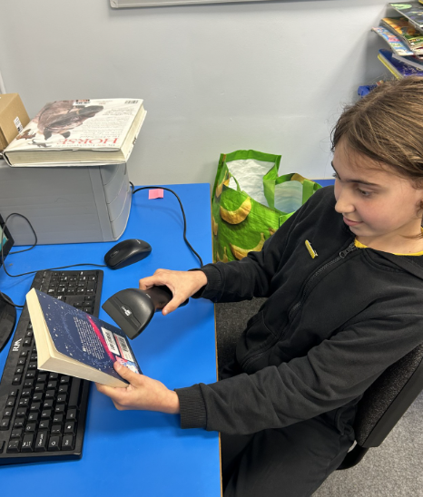

Our Library Garden
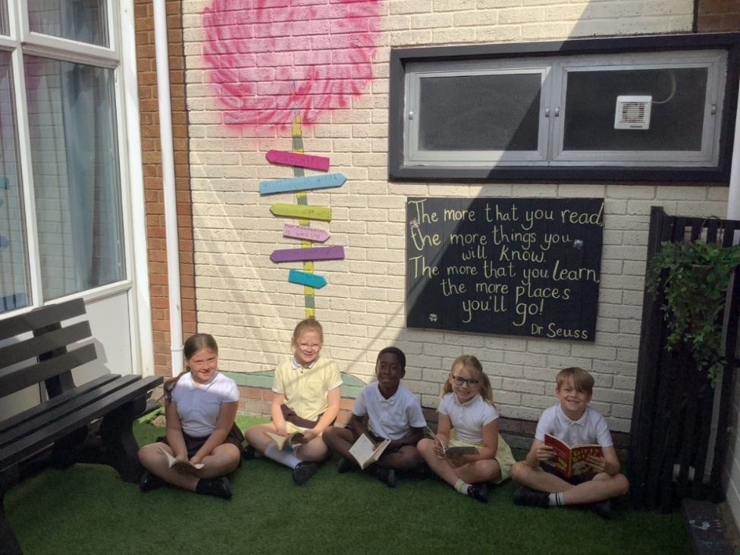
After lots of hard work from Mrs. Page and some of our school council children, the library garden is finally open! On warm days, children can now choose a book and enjoy reading outside in this lovely space.

Why is reading for pleasure so important?
At St Clare’s, we know that reading for pleasure is one of the most powerful ways to support a child’s learning and well-being. When children read for enjoyment, they build vocabulary, improve concentration, and develop empathy by seeing the world through different characters’ eyes.
But most importantly, reading sparks curiosity and imagination. Whether it's a laugh-out-loud story, a magical adventure, or a fascinating fact book, getting lost in a good book helps children become confident, creative thinkers.
We encourage all our families to make time for reading at home—just 10 minutes a day can make a big difference. Let’s keep nurturing a lifelong love of reading, one page at a time!
Reading Challenge!
Here’s a sneak peak at the exciting new books in our current reading challenge. Children reading three or more times a week at home are given a ticket which they post in their favourite book. One lucky winner is selected at random each half term and win the book!
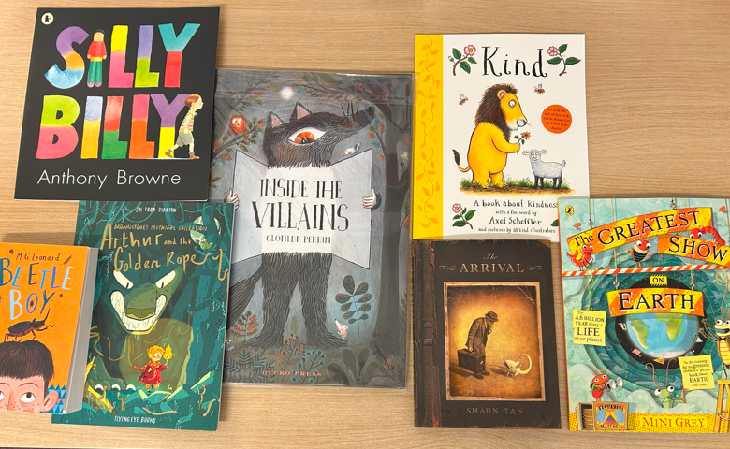

The Summer Reading Challenge
Last term, many of you signed up for a Clacton Library card — so why not take part in this year’s Summer Reading Challenge? If you don’t have a card yet, you can get one from the library. Along with the challenge, the library also offers other free activities for children!


