



St. Clare’s Behaviour and Relationships Policy

(including support for children with social,
emotional and mental health needs)



March 2026

Contents

 | Page
School Values and School Ethos | 3
A Relational Behaviour Model | 3
General Expectations | 4
What do we do to reward positive managements of behaviour? | 5
Viewing behaviour as a learning process | 5
Our general responses to mistakes and incidents | 5
Using logical consequences | 6
Ways to record incidents | 9
How we support children with additional SEMH needs | 9
Our Principles- the things we will do as adults | 10
Responsibilities | 10
Harm from dysregulated behaviour | 11
Risk Assessment Process | 12
Physical intervention (control and restraint)- the use of reasonable force | 12
Screening and searching pupils | 13
Further Guidance | 14
Appendices  Appendix 1: Roots/Shoots/Fruits  Appendix 2: STAR Analysis  Appendix 3: Three Stages to Supporting the Understanding of Behaviour – A TPP guide  Appendix 4: Environmental Checklists for pupils with additional Social Emotional and Mental Health (SEMH) needs  Appendix 5: A Tool for Understanding and Reframing Behaviour  Appendix 6: Key Questions for the Risk Assessment  Appendix 7: Individual Harm Reduction Plan  Appendix 8: The Six Core Strengths Assessment | 15  16  17  21  26  28  29  30

School Values
At our school we believe in the importance of relationships, ensuring children feel valued, safe and secure, providing a sense of connection with a member of staff and a belonging to the whole school community.

Our school values (resilience, inclusion, compassion, love, respect, honesty) reflect the values of the Essex approach to understanding behaviour and supporting emotional wellbeing known as Trauma Perceptive Practice (TPP)
- Compassion and Kindness
- Hope
- Connection and Belonging

We endeavour to make sure that at our school these values run through all the school policies and practice.

School Ethos

This Relationships and Behaviour Policy is designed to support the way in which all members of the school can live and work together in a supportive way. It aims to promote an environment where everyone feels valued, respected, happy, safe and secure and able to learn.

We value each individual child and work with families, the community and beyond to offer diverse experiences and support for pupils and families. We develop children to be confident, life-long learners and compassionate, respectful members of their community and the world.
We always prioritise the safety of our pupils and staff. Everything we do in school is underpinned by our safeguarding procedures.

All staff are trained in TPP. Positive relationships between staff and pupils are an inherent part of our school culture. All our staff work to support children in learning and social development. When appropriate, the support will be adapted to meet specific social, emotional and mental health needs which require a personalised approach.

A Relational Behaviour Model
At our school we adopt and use the relational behaviour model which is the TPP approach. The following table explains how it is applied
Behaviour is something to | interpret
Children and young people | are prone to make mistakes and highly responsive to the environment and the context
Behaviour management is predominantly through | relationships
Children who don’t manage should be | understood and included
Boundaries and limits are to | keep everyone safe and to meet everyone’s needs
Rules should be | developed together and adapted where needed
Consequences are | only used within a process of restore and repair
‘Inappropriate’ behaviour is | a sign of unmet need, stress (difficulty in coping), lack of understanding and skills
The causes of the difficulties are | mostly in the environment and within the context of relationships
The solutions lie in | understanding what the behaviour tells us about the child and their need
Practice and policy effectiveness is measured by | wellbeing and the capacity to adapt and make reasonable adjustments to meet the needs

General Expectations

We have high expectations for our pupils, while recognising some children have specific needs. The following expectations cover all times of the school day and where children are representing the school out of hours or off site. This means we

- encourage a positive attitude to learning within a safe, happy environment.
- promote high expectations and enable pupils to become independent and responsible learners.
- encourage a sense of respect for our community and our environment.
- believe that clear, consistent routines and systems are essential to support development and ensure the health, safety and wellbeing of everyone in our school community.

It is everyone’s responsibility to remind and support children and young people where these expectations are not met. Equally it is important to comment positively when they are. Staff model expected behaviours, attitude and habits.

Any behaviour that falls below the expectations of our school (e.g. disruption to learning, unkind or inconsiderate actions), will require some level of intervention. As every interaction is an intervention, it is important to remember that the strongest approach to support a child is through their relationship with the adult. At all points we try to ensure we keep a strong connection with the child having difficulties. We use positive recognition, as appropriate, to ensure the children know we are still there, and we recognise their effort and any changes they have made.

Ensuring good routines are in place is paramount to good behaviour management practice at our school:
- Start and end of day
- Transition times
- Lining up incl. assemblies/masses/prayers
- Getting changed for PE
- Moving around the school
- Break and Lunchtimes
- School outings
- after school clubs

Specific behaviour rules are displayed in each classroom and taught to children.

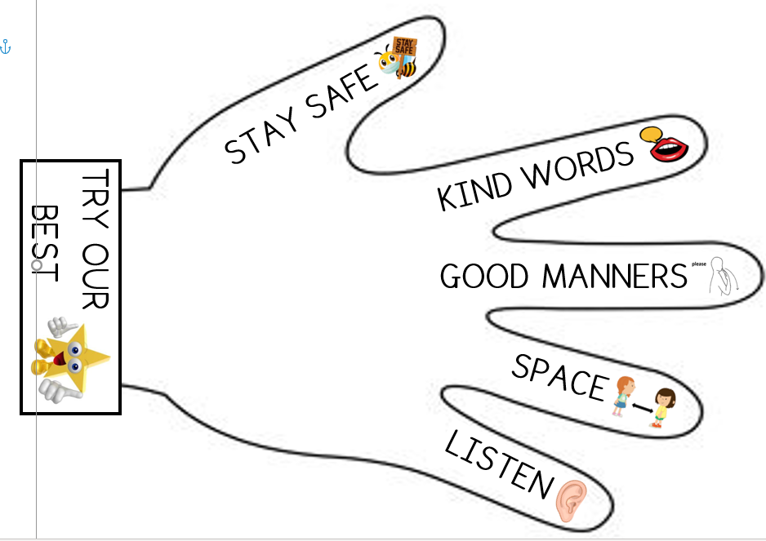

What do we do to reward good behaviour?

Specific verbal praise
Stickers/stamps
Privileges/special jobs/being chosen to represent the school or to attend a club
special outings/whole class non-uniform day
Sharing good behaviour/work with other members of staff including SLT
DoJo points and a class based reward linked to points
DoJo messages sent to parents
Star table at lunchtimes (weekly)
Celebration Assemblies with certificates presented by the Headteacher
Value ambassadors and value time

Viewing behaviour as a learning process

At our school we accept and understand behaviour as a learning process. Children will push limits, boundaries, and societal norms as part of their development. They may also react in different ways to stress, boredom, lack of understanding, over-excitement, and disappointment. At our school staff view behaviour mistakes as inevitable. This means that we offer support and guidance to the children so they can make helpful and positive choices. We do this by listening to the children and explaining the impact their behaviour has on others (known as co-regulation). The approach we strive for is based on the premise of ‘connection before correction’ (being proactive and positive as demonstrated within the school’s core values).

Our general responses to mistakes and incidents

Our school believes in the power of using restorative approaches. These happen in the classroom throughout the day. Such processes do not shy away from using consequences, such as loss of privileges where logical, they also focus on the need to take responsibility This might mean a sincere apology (verbal, written, picture or an action) followed by an act of kindness. Such approaches encourage the children to think not only of the consequences of their behaviour on themselves, but also to consider the impact of their actions on others.

In using this process at our school, we use four questions:
• What happened?
• What were you feeling or thinking at the time?
• Who has been affected?
• What can we do to make things right? (What should happen next?)

Using this approach, children have the opportunity to reflect on what’s happened and the impact this may have had on others. They can have the chance to show the person that has been affected by their action that they are sorry. This can be in the form of verbal, written, picture, or an action.

Where possible, a logical consequence (natural reparation) is used e.g., clean graffiti off the door, clean up the mess, pay for replacement of item. Where this is not possible a close alternative should be used.

At our school the staff work with the children to ensure that they have learnt from an incident so that they can be successful next time. Teaching of the skills required may be necessary to enable a different outcome next time. The impact of our approach is evident in the relationships forged throughout the school. The strategies involved, which include active listening, respectful discussion and taking ownership of issues, result in a positive ethos.

Using logical consequences

The use of consequences
Consequences are a useful response to behaviours, remembering that some behaviours result in positive consequences. When responding to unwanted behaviour, the consequences we use in our school always have a clear link to the incident and help the child to learn how to behave more appropriately should a similar situation occur, tailoring this to the needs of the individual.

It is helpful to view consequences as protective and / or educational. Best practice suggests that all protective consequences should run alongside educational consequences, as it is unlikely that long-term behavioural change will occur without this.

Protective consequences: these are required to protect the rights of others and keep a child or young person safe. At our school this may include:
- increased staff ratio
- change of school day / timetable
- arrangements for access to outside space
- appropriately used brain breaks
- adapted teaching space
- appropriate use of suspension (using the time to reflect, amend plans and identify needs and other appropriate interventions to support the child or young person upon return).

Educational consequences: at our school we use these to teach, encourage, support and motivate the child to behave differently next time through better understanding. Examples include:

- ensuring the child completes the task they have disrupted
- rehearsing / modelling situations through intentional teaching of prosocial behaviour
- ensure the child assists with repairs where they have caused damage (when possible and practical)
- intentionally provide educational opportunities for the child to learn about the impact of certain actions and behaviours
- provide the child with an opportunity to ‘put things right’ through a process of reflecting, repairing and restoring relationships (a restorative approaches is an example of one).

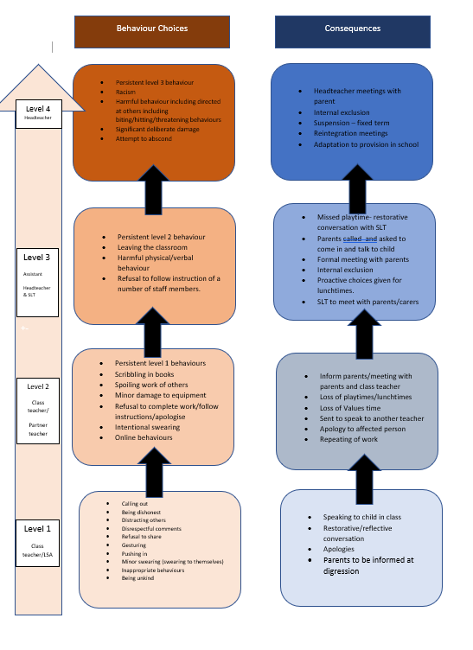

Ways to Record Incidents of Concern

We have a clear process and system in place to record incidents that occur. We use the information effectively to enable strategic oversight and to influence and review practice.

Contact parents: preferably face to face, phone or dojo if unable to contact
CPOMS record (of persistent or serious behaviours)
Incident reported in a home-school book (if a pupil is assigned one)
Star Analysis Form completed (if it is a serious physical violent incident)
Racist Incident form completed (if an incident of discrimination was completed)

How we support children with additional Social, Emotional and Mental Health needs

We recognise that children and young people may experience a range of social, emotional, mental health needs which present themselves in many ways. These may include children displaying challenging, disruptive or stress related behaviour. These behaviours may reflect underlying social interaction difficulties, sensory or medical needs or clinically diagnosed needs such as attention deficit disorder, attention deficit hyperactive disorder, foetal alcohol disorder or attachment difficulties.
We will always endeavour to understand behaviour, support emotional wellbeing and make reasonable adjustments to our provision. In Essex, this is done in the context of One Planning. We also recognise the needs of children and young people with Special Educational Needs and Disabilities (SEND) and follow the policies and procedures associated with supporting these children, including but not limited to, the SEND Code of Practice, Equal Opportunities and Disability Act. This will be done through collaborative work of staff, family and professionals.

We understand that the behaviour(s) most likely comes from a place of stress anxiety, fear or as a result of a barrier to learning. We have a duty to strive to help children and young people to return to a place of regulation, within their ‘Window of Tolerance’, as only then will the children be able to learn, connect and thrive.

Ways to Support Understanding

At our school we believe that understanding what the behaviour is communicating to us is the first part for planning a response.

The following appendices contain ways to help us to understand the behaviour

Appendix 1: Roots/Shoots/Fruits
Appendix 2: STAR Analysis
Appendix 3: Three Stages to Supporting the Understanding of Behaviour – A TPP guide
Appendix 4: Environmental Checklists for pupils with additional Social Emotional and Mental Health (SEMH) needs
Appendix 5: A Tool for Understanding and Reframing Behaviour
Appendix 6: Key Questions for the Risk Assessment
Appendix 7: Individual Harm Reduction Plan
Appendix 8: The Six Core Strengths Assessment

Our Principles - the things we will do as adults

- Model compassion and kindness, provide hope and support connection and belonging
- Understand that any event in a child’s life can impact on how they think, feel and act
- Use of logical (natural) consequences rather than just simply punishments or sanctions
- Provide routines, set limits and have consistent boundaries
- Model how to regulate emotions
- Prioritise relationships to ensure all children feel safe and secure

Our Responsibilities

All staff
- Are responsible for supporting the safety and other needs of children across the school. Where a child is seen to be having difficulties, they should be treated with respect and understanding
- Always endeavour to have private discussions with children in order to help support any issues that are arising
- Take responsibility for their own personal safety and wellbeing
- Contribute actively to risk assessment, and be familiar with policies, guidelines, control measures, instructions and reporting procedures
- Participate positively in appropriate training.
- Follow the principle of ‘connection before correction’

Head Teacher
- Leads on all aspects of this policy
- Is the only person authorised to exclude or suspend a child (or the deputy Head Teacher in their absence)
- Ensures that risk assessments are carried out when required and that appropriate measures are implemented
- Ensures that all staff receive regular purposeful training to support relationships and minimise risk
- Ensures that all staff are provided with clear instructions for reporting incidents of harm and that all such reports are thoroughly investigated and responded to
- Offers and provides appropriate support to staff following a stressful incident

Other Senior Leaders
- Lead on all aspects of this policy
- Ensure the policy is implemented effectively
- Ensure all staff are appropriately trained
- Oversee the specific needs of all pupils across the school
- Provide support to staff, pupils and parents as necessary
- Link with outside agencies to access additional services
- Ensure that all tracking and reporting of incidents and additional needs are up to date

Classroom Staff
- Plan the teaching and learning accessible for all children
- Include parents/carers in personalised planning for their child
- Communicate regularly with parents/carers about their child’s needs
- Provide specific support for children and young people experiencing any difficulties, whether this is an ongoing need or a short term difficult a child may be having.

Family
- Inform the school of any concerns about changes in their child’s behaviour, emotional wellbeing or mental health
- Have open conversations with the school
- Engage with support offered by the school and other agencies to further support their child’s needs

Governors
- Ensure that appropriate policies are in place, that they are regularly reviewed, and their effectiveness monitored
- Consider families’ representations about an exclusion
- Undertake their statutory role around exclusion
- Ensure that all staff receive purposeful training in order that they can undertake their role

Harm from dysregulated behaviour

Our school always prioritises the safety and welfare of all staff and children, recognising that everyone should have access to a safe and supportive environment. Any incident (verbal or physical) which compromises safety can be perceived as harmful. Our staff understand through training that this behaviour is not necessarily deliberate, rather it often is a stress response.

In case of attempts to abscond or any other serious and dangerous behaviour, children may be escorted to a safe place or a Restrictive Physical Intervention can be used. This will be discussed with the children’s parents and where appropriate written into an individual Harm Reduction Plan/Risk Management Plan.

Supporting those who have been harmed

Our staff and children and young people receive the individual support they need in response to any incident where the behaviour has compromised the wellbeing of someone else, causing harm. Occasionally despite all reasonably practicable measures being taken, prevention unsuccessful, and someone is harmed. At these times our school ensures that the harmed person (adult or a child) is supported.

We always consider the following:
- are they physically safe and protected?
- do they need immediate first aid & medical treatment?
- is there a need for immediate police involvement?
- ensure they have the opportunity to talk about the incident either with a trusted person or other independent service
- give reassurance to reduce feelings of guilt and/or anxiety

Our school recognises that some people are more at risk than others in their work, and where this is the case, we ensure there is appropriate support available.

Risk Assessment Process

In our school we use a risk assessment process which is recorded as Harm Reduction Plan/ Risk Reduction Plan as the starting point for preventing harm for identified vulnerable children. It identifies what is likely to cause stress to them, using all the information known about the children. Once all this information is to hand, a strategy for supporting a situation appropriately and keeping everyone safe can be developed.

Physical intervention (control and restraint) - the use of reasonable force

At our school we make sure we are aware of our duties of care and adhere to the law. The law states that it is permissible to use reasonable force to prevent pupils committing an offence, injuring themselves or others, or damaging property, and to maintain good order and discipline in the classroom.

The use of physical intervention techniques is only one aspect of co-regulation and is usually the last resort when it is deemed absolutely necessary. It may resolve a short-term situation, but the long-term aim must be to help the child to be able to self-regulate during times of stress.

If such actions are necessary, the actions that we take aim to use the minimum amount of force necessary for the minimum amount of time necessary. Where physical intervention is needed, this is recorded and reported immediately to the head teacher.

At St Clare’s we use the teamSOS app to support staff when an incident occurs which requires adult support. This is an incident response system for schools and other organizations to manage emergencies and daily incidents. Its purpose is to safeguard staff and pupils by providing instant alerts, two-way communication, and access to guidance and protocols, enabling a quick and effective response to a variety of situations like lockdowns, medical emergencies, and safeguarding issues.

Team SOS, an alert system is employed within the school to enable staff to communicate with one another if the need arises to support a child who is dysregulated.

Our school follows this Essex Guidance ‘Understanding and Supporting Behaviour - Safe Practice for Schools and Educational Settings (Including the use of restrictive / non-restrictive physical intervention)’
It can be found here
Social, Emotional and Mental Health Portal for Schools, Colleges and Settings - Essex Guidance and Let's Talk Resources

Within this guidance, it is regarded as best practice to record every incident where the use of restraint has been deemed absolutely necessary and to follow the other recommendations set out in this document.
This includes reporting to ECC via MySafety.

The MySafety system is used to record all accidents, violence, work related Ill Health and near misses.

Click here to log an incident (please use the Access Token: ABC123)

Where it has been deemed necessary to use a restrictive physical intervention, the detail of this should be accurately recorded and the incident communicated to parents. Parents should be informed of the incident initially by phone and it should then be followed up in writing.

Screening and searching pupils

At our school we are all aware that there are two sets of legal provisions which enable school staff to confiscate items from pupils:
‘The general power to discipline’ and the ‘Power to search without consent’; from the ‘Behaviour and discipline in Schools - Advice for headteachers and school staff’ (January 2016)
Behaviour and Discipline in Schools - A guide for headteachers and school staff final draft.docx (publishing.service.gov.uk)

From this guidance our staff understand that they may confiscate items that are of high value, deemed inappropriate and are against the school policies or are causing concern. Where a specific policy about the item does not exist, the teacher should use their discretion about whether the item is returned to the child or to their parent/guardian. Items returned to the child should usually be returned no later than the end of that school day. If the item needs collecting by a parent/guardian, the teacher should ensure that the parent/guardian is made aware that an item has been confiscated – either through the child or via text/phone call. Where the item is of high value or deemed inappropriate, contact should be made directly with the parent/guardian.

Staff do have the power to search without consent for “prohibited items” including:

• knives and weapons
• alcohol
• illegal drugs
• stolen items
• tobacco and cigarette papers
• fireworks
• pornographic images
• any article that has been or is likely to be used to commit an offence, cause personal injury or damage to property; and any item banned by the school rules which has been identified in the rules as an item which may be searched for. The legislation DfE sets out what must be done with prohibited items found as a result of a search.

Further Guidance

- Keeping Children Safe (DfE, 2021)

- Reducing the Need for Restraint and Restrictive Intervention (DfE, 2019)

- Use of Reasonable Force (DfE, 2013)

- Behaviour and Discipline in Schools (DfE, 2016)

- Exclusion from maintained schools, academies and PRUs in England (DfE, 2017)

- Searching. screening and confiscation (DfE, 2018)

- Positive environments where children can flourish (Ofsted 2018, updated 2021)

- Creating a Culture: how school leaders can optimise behaviour (DfE, 2017)

Notes on the Following Appendices

These contain examples of recording and assessment tools. You may well have other tools and systems for doing this.

For help as to which of these you may wish to include you will be able to speak to your link Inclusion Partner and/or Educational Psychologist about this.

Appendix 1: Roots/Shoots/Fruits

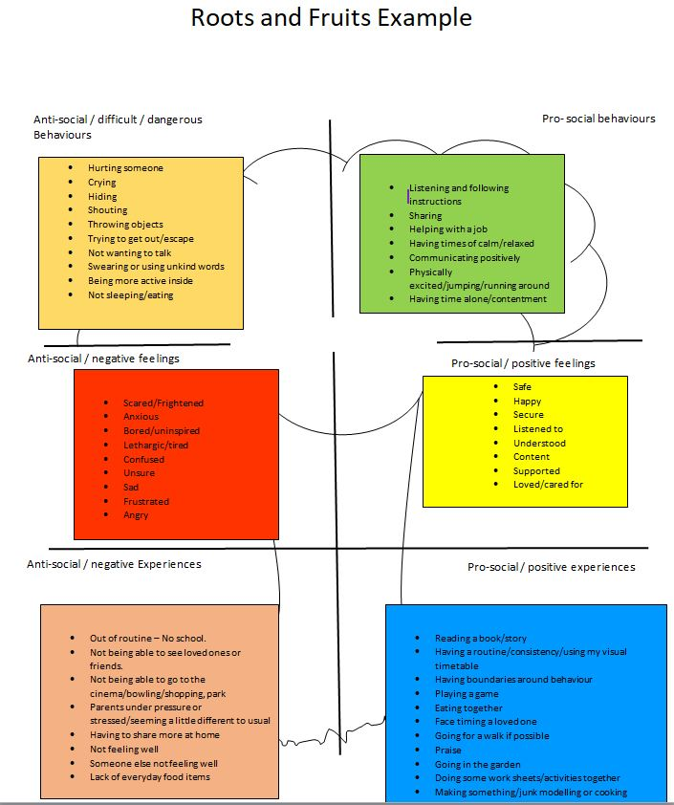

Appendix 2: STAR Analysis

What happened at the time? | What we could do differently to promote positive communicating behaviour in the future?
Setting (Time, environment, relationships, etc.)

Trigger (stressor)

Action (What happened?)

Result (What happens next?)

Appendix 3: Three Stages to Supporting the Understanding of Behaviour – using the TPP guide

‘A significant proportion of children and young people may need educators to anticipate possible stressors in the normal course of the school day, and to help prevent and manage these. A working assumption for highly fearful or aggressive behaviours, should be that the child or young person has, or is, experiencing stress/distress. It is important and helpful therefore to understand ‘challenging behaviour’ as a communication or sign of distress or fear. Subsequently this should lead adults to offer different, alternative and more helpful resources which can ensure interventions are supportive and nurturing rather that punitive or shaming.’
TPP Trainers’ Manual page 5

Stage 1  Use the Emotional Pot to get to know the child and the family the big picture (holistic sense)  Adopt an attitude of curiosity and reflect on the child’s circumstance. Sensitively involve all parties who know the child well to gather information. For some CYPs this might involve pupil or parent interview as well as reflection with the staff members working with the child in school. | 
Stage 2  Be the Stress detective to find/observe/notice the stressors across the day  Stressors could be related to the time of day (when a CYP is hungry or following transitions), places or curriculum subjects, other people (adults and peers). Explore all variables that exist within the CYP’s day to notice commonalities and differences. | 
Stage 3  Analyse and plan to enable informed co-regulation  After gathering assessment information, begin to make a plan for how to support the CYP’s co-regulation. Recognise that the adults will need to change their behaviour first. |   

These 3 stages are explained in more detail below and can be used collaboratively in your school/setting to enable you to more effectively support the child or young person.

Stage 1.



Use the Emotional Pot to see what’s filling it up.

- Why? Why Now?
- What’s happening? What’s happened? What’s going on? (Include assumptions)
- Feelings: How might they or how do they feel in response to these things?
- Thinking: How might they be thinking? What might they be thinking?

What’s happened? | Going on? | Feeling? | Thinking?
Possible examples  Death of a pet/loved one, parental separation, domestic abuse | Possible examples  Angry, withdrawn, crying, swearing | Possible examples  Alone, excluded, confused | Possible examples  Why me? I am useless…

- What behaviours are you seeing, when and why?
- How can these behaviours be reframed?

Use empathic TPP language to reframe the behaviour as communication in response to stress – See TPP element 5.

What are you seeing? | Reframe this behaviour
An example linked to above: parental separation  Crying  Approaching peers with aggression | An example linked to above: parental separation  Not able to cope and therefore seeking connection  In the ‘fight’ response

Use – ‘A Tool for Understanding and Reframing Behaviour’ see Appendix 4


Stage 2.

Be the Stress detective- find/observe/notice the stressors across the day

- In your ‘team around the child’ hold a discussion about the child/young person, decide on the stressors you are going to initially monitor e.g. time of day
- Monitor through observation the stressors identified across the day
- You may need to do this for a number of stressors to build a full picture of the communicating behaviours and stress responses e.g. day of the week, adult teaching/supporting. This can be plotted on a table such as below.

States of arousal:
Hyper aroused
Terror | ✔
Fear |  |  |  |  | ✔
Alarm
Alert |  | ✔ |  |  |  | ✔
Window of tolerance
Calm/engaged |  |  | ✔ | ✔ |  |  | ✔
Hypo aroused
Low |  |  |  |  |  |  |  | ✔ | ✔
Stressor:  - Time of the day | 8:45  am | 9:15  am | 10:00  am | 10:30  am | 10:40  am | 11:00  am | 12:00  pm | 2:00  pm | 3:00  pm

You can also use the STAR analysis framework to help you monitor trends and patterns (Appendix 2)

Stage 3.

Plan for co-regulation to help prevent the overflow of the ‘emotional pot’

 | The adult provides opportunity to co-regulate by turning the tap.  Self-regulation will follow on from this. Children always need to be successfully co-regulated in order for them to be able to successfully self-regulate (soothe themselves).
 | The level then falls to one of emotional containment.

- The personalised stress/distress management plan

Adult Response Plan

Window of Tolerance  Description  What the child is like when regulated, calm and engaged? | How best to support and maintain this and support regulation
Dysregulation  Description  What are the first signs that things are becoming too stressful? | Strategies to support and to co-regulate
Where does this stress behaviour lead to next? | What we are trying to avoid?
Hyperarousal | Interventions necessary to support, co-regulate and keep everyone safe
Hypoarousal | Interventions necessary to support, co-regulate and keep everyone safe

Appendix 4:

Environmental Checklists for pupils with additional Social Emotional and Mental Health (SEMH) needs

Consider the needs of a specific pupil before exploring the school environment with them in mind.

The questions are designed to be prompts to inform One Planning.

The individual checklists complement each other, but separate different school environments in order to consider a child’s presentation in different contexts thus drawing attention to differences and similarities. Some questions are therefore repeated.

Safety | Y/N n/a | What needs to be done
If deemed appropriate, has a risk assessment been completed to assess and manage risks involved in the provision for the pupil?

Have actions been taken to address identified risks?

Have staff received appropriate training as part of addressing identified risks?

Have parents/carers been involved in the assessment and planning to support the safety of their child in school?

Have parents/carers been informed of any incidents where safety of their child has been of concern?

Is the child/young person feeling secure in their relationships with adults and peers?
(see Social Interaction section)

The SEND Environment | Y/N n/a | What needs to be done
Has a One Page Profile been completed for this child/young person?

Are procedures in place to share the One Page Profile with familiar adults and those unfamiliar with the child/young person eg. supply teachers?

Is One Planning in place for this child/young person?

Is there a current Adult Response Plan in place for the child/young person?

Are major/repetitive incidents or communicating behaviours which cause concern analysed so changes can be planned for? (using ABC/STAR analysis tools)

Has the school/setting communicated appropriately and effectively with the child/young person’s parents/carers?

Does the child/young person separate appropriately from parents/carers at the start of the day and return happily to them at the end of the day?

Are parents/carers requesting parenting support at home and have they been appropriately signposted?

Are there any outside agencies already involved in the support for the child/young person?

If outside agencies are involved, have their recommendations been followed effectively?

Have interventions provided by outside agencies been delivered?

The Learning Environment | Y/N  n/a | What needs to be done
Have the child/young person’s views about their learning been sought?

Is the child/young person able to access support quickly in the classroom when necessary?

Is a Learning Support Assistant directed to support the pupil?

Does the Learning Support Assistant have a good understanding of the child/young person’s needs?

In line with best practice, does the Learning Support Assistant offer hover support?

Are there procedures in place to regulate and monitor the use of personalised provision if necessary?

Is there safe place that the child/young person can access within the classroom when necessary?

Is the child/young person seated in a place that supports their needs eg. away from distractions or close to the exit?

Is the child/young person able to attend to and engage with whole class learning?

Is the child/young person seated with good role models and away from others who may prove distracting?

Is the child/young person able to work effectively with peers in a group?

Is the child/young person able to focus and complete independent work for an appropriate period of time?

Are adults using positive language around and to the child/young person?

Are adults using the language of Growth Mindset to support the child/young person?

Are the child/young person’s feelings and emotions acknowledged?

Do staff react consistently to communicating behaviours?

Are rewards and consequences given fairly and consistently?
Is the child/young person given access to sensory, movement or brain breaks when necessary?
Have the child/young person’s sensory needs been explored? If so, has provision been made for them?

Does the child/young person have good relationships with the adults in the classroom?

Does the child/young person enjoy being given responsibility?

Are there times when the child/young person can focus on work for longer periods of time?

Are there specific subjects that the child/young person finds more difficult to engage with, such as Literacy or PE?

Is the child/young person able to work outside of the classroom when appropriate?

Is the child/young person supervised adequately when out of the classroom?

Do all staff know how to react to the child/young person and his/her communicating behaviour when encountering them in the school?

Is the child/young person able to follow normal school rules and routines without additional supervision e.g. using the toilets appropriately, sitting with peers in assembly?
Is the child/young person able to line up with their peers?

Does the child/young person have any other significant relationships with staff or children around the school?

Social interaction  (less structured environments) | Y/N  n/a | What needs to be done
Have the child/young person’s views about friendships and relationships with adults and peers been sought?

Does the child/young person have friends they can play with?

Is the child/young person able to interact appropriately with other children beyond their friendship group?

Is the child/young person able to play safely and independently?

Are there systems in place that allow the child/young person to access play opportunities eg. play leaders, equipment?

Are there alternative, more structured environments available within the school available to support the child/young person eg. lunch clubs?

Does the child/young person know how to access adult support in less structured environments?

Do the adults supervising have a clear understanding of the child/young person’s needs?

Do staff react consistently to communicating behaviours?

Are rewards and consequences given fairly and consistently?

Appendix 5- A Tool for Understanding and Reframing Behaviour

Describe the behaviour  Review and be curious | Reframe the Behaviour  from for example: “He’s just lazy” or  “She just wants to get attention”  to something more helpful.  Examples of reframing- | Reflections  How is this behaviour understandable?  What’s getting in their way/what are the barriers?  How can we help? | Adult response  What do we need to intentionally teach?  Find the barriers and remove them
Be the stress detective  - why and why now?  What is the typical adult response?  - Is there an adult response plan?  - Is the plan helpful, shared, used and understood?  - Is there a personalised stress/distress management plan?  Consider the environment  Is there adequate differentiation for learning and sensory needs and personal strengths  How are rules shared, talked about and explained? | Avoidant: in ‘fight/flight’ survival mode  Defiant: in ‘fight/flight’ survival mode, coping with threat  Aggressive(controlling): outside window of tolerance. Dysregulated in the hyperarousal state as a result of becoming distressed. Now in ‘fight’ survival mode, adaptive strategy to manage underlying vulnerability e.g. fears, anxieties, helplessness, confusion, shame, or feeling frightened  Attention seeking: attachment/connection needing: they need time and attention for something in that moment (they do not feel safe and secure yet and trying to gain a sense of belonging)  Withdrawn: cautious possible indicator of an emerging ‘flight/hypoarousal and or freeze’ response being used to cope with the situation  Rude: self-protective: “I need you to know how I feel so I’m going to make you feel like it too so you will help me”, or “I don’t think you like me/don’t care”. In fight mode.  Not engaging: doesn’t feel safe yet. possible indicator of an emerging dysregulation response being used to cope with the situation. | The impact of trauma  For example-How have any adverse experiences affected their ability to trust, share attention? (confirmed or assumed)  Feelings fuelling the behaviour  Is the child projecting their feelings onto you? Are you inadvertently re-enacting previous relationships? Are you too distressed by the behaviour to co-regulate?  Attachment history- what is their survival strategy?  How have earlier experiences shaped the child’s preference for connecting with others? How is this being challenged/affirmed?  Social development  Can they play with or are they better alongside? Can they share and negotiate? Do they show empathy? | Structure and Predictability  Visual routines, preparation for transitions, opportunities for sensory input and relaxation  Adapt the learning  Small steps, time limited, clear and realistic expectations, choice and use the child’s strengths Rhythmic/repetitive intervention/support.  Relationships with the staff  Compassionate and kindness in the greetings, verbal language and body language; genuine empathy for tough times, exploration of feelings, use of regulate/relate/reason. Use PACE.  Relationships with peers  Role playing and social stories, mentors, clear roles in any group activity, reduce competition, increase play and fun.

Blank template
A Tool for Understanding and Reframing Behaviour

Describe the behaviour  Review and be curious | Reframe the Behaviour  from for example: “He’s just lazy” or  “She just wants to get attention”  to something more helpful  Examples of reframing | Reflections  How is this behaviour understandable?  What’s getting in their way/what are the barriers?  How can we help? | Adult response  What do we need to intentionally teach?  Find the barriers and remove them

Appendix 6: Risk Assessment

Key Questions for the Risk Assessment

- Assess the risk and reducing the potential for harm
Adopting precautionary and preventative steps which help to avoid, prevent, minimise or mitigate incidents where staff can be harmed. Maintaining a sense of proportion in relation to the assessed risk. Best practice will be to involve parents/carers and the CYP in this risk assessment process.

Possible questions to inform the risk assessment
- What harm could occur and how severe could this be? How likely is this harm?
- What information is provided for staff, how is it communicated?
- Is the right level of training provided to relevant staff?
- Are there changes needed to the way people carry out their duties or where they work?
- Has there been sufficient accounting of the site layout and the knowledge of the immediate working environment?
- Incident recording and response to incidents.
- How is any information, reports, involvement with other agencies such as the police and children’s social care shared?

The assessment will include:
- Identified vulnerable CYP (those that are most likely to become dysregulated when, where including activities and areas).
- Existing preventative measures and evaluation of the other potential risks.
- Additional preventative and control measures identified, including timescales.
- Communication procedures and review arrangements.

2. Write an action plan
Any actions should be written monitored by Head Teacher/Senior Management and Governors to ensure that all items identified have sufficient resources allocated and have been addressed. The plan should be fit for purpose and tailored to managing the specific risk presented by identified CYP or groups of children and young people. The plan should include the following:
- Action required,
- Action by whom
- Risk priority
- Projected timescales
- Date completed

3. Monitor, Review and update the assessment
Any risk assessment should be regularly reviewed and updated. It also should be visited again following a significant incident to reflect on any learning or additional protective measures.
Appendix 7.

Individual Harm Reduction Plan

Name: .. | DOB: | Date: | Review Date:

Photo | Harm reduction measures and differentiated measures (to respond to triggers).  Triggers  Reduction Measures:

Pro social / positive behaviour | Strategies to respond
Give examples

Anxiety / DIFFICULT behaviours

Give examples
DANGEROUS behaviours - dysregulation

Give examples

Post-incident recovery and debrief measures
- Lead a restorative conversation when ………… is calm: 1. Tell me what happened. 2. What were you thinking/feeling at the time? 3. Who was affected? / How do other people feel now? / What can we do to make things right?
- In the case of a suspension, a re-integration meeting must be held.

Appendix 8
The Six Core Strengths Assessment

https://schools.essex.gov.uk/pupil-support-and-wellbeing/social-emotional-and-mental-health-semh/semh-resources/assessment

