St. Clare's Catholic Primary School

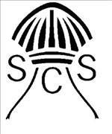

PRAYER AND LITURGY POLICY
Collective Worship

June 2026

"St Clare's Catholic Primary School is part of Primary Excellence Trust - A Catholic Education Trust which is a charitable company limited by guarantee registered in England and Wales (registered number 8068528).
Registered office: Priory St, Colchester, CO1 2QB"

"St Clare's Catholic Primary School is part of Primary Excellence Trust -
A Catholic Education Trust which is
a charitable company limited by guarantee registered in England and Wales (registered number 8068528).

Registered office: Priory St, Colchester, C01 20B"

INTRODUCTION
‘For where two or three are gathered in my name, I am there among them’ (Matthew 18:20). This familiar saying of Jesus provides the starting point for understanding prayer and liturgy within St Clare’s Catholic school. Whenever we come together to pray or to celebrate the Sacraments or to hear the scriptures, Christ is present and active.

Just as Our Lord Jesus Christ is at the heart of all our prayer and liturgy, so too he is at the centre of every Catholic school. His Gospel is the reference point for its ethos and values; he offers the definitive example of the educator. Joining Christ in praise of the Eternal Father and united by the Holy Spirit in making intercession for the world through prayer and liturgy lies at the heart of the daily life of the school. The quality of the prayer and liturgy in school not only gives honour to God but forms the spiritual and ethical life of pupils and staff alike.
To ensure that the Lord Jesus Christ is at the centre of a Catholic school, prayer and liturgy must be at the heart of its community life. They are essential to the school’s Catholic life and mission.
The Catholic school is well aware that the community that it forms must be constantly nourished and compared with the sources from which the reason for its existence derives: the saving word of God in Sacred Scripture, in Tradition, and above all in liturgical and sacramental Tradition, enlightened by the Magisterium of the Church.10
The community of a Catholic school will generally be inclusive of people who are not Catholics or Christians. This context provides Catholic schools with a unique opportunity to present, in an authentic way, our tradition of Catholic prayer and liturgy, while at the same time providing a welcoming environment for all pupils and staff. In order to respond to this most fruitfully, we are called to understand the tradition of the Catholic faith and maintain an approach that respects the integrity of all members of the school community.

The context of this prayer and liturgy policy
‘The celebration of Catholic liturgies and prayers as an integral part of the learning and teaching should enable the school community to become reflective, experience the presence of God and should develop a mature spiritual life.’ (Marcus Stock (2012), Christ at the Centre, Catholic Truth Society, 23.)

Statement of requirement
The law requires all maintained Catholic schools to provide an act of daily collective worship (prayer and liturgy) for all pupils, including those in the sixth form (Section 70, 1988 Education Act) that is in accordance with the rites, practices, disciplines, and liturgical norms of the Catholic Church (School Standards and Framework Act 1998, schedule 20; Instrument of Government, clause 2). Academies in England are required by their funding agreement and Articles of Association to comply with similar requirements (The Mainstream Academy and Free School: Supplemental Funding Agreement, December 2020; Model Articles for Catholic Academies, February 2019).

The law requires all maintained schools to recognise and respect that parents have the legal right to withdraw their children up to the age of 16 from prayer and liturgy (School Standards and Framework Act 1998, s.71(1A)). Sixth-form pupils can choose to withdraw themselves from prayer and liturgy (School Standards and Framework Act 1998, s.71(1B)).
The school’s provision for prayer and liturgy will fulfil pupils’ entitlement to experience the range of liturgical treasures of the Church, including a shared repertoire of prayers and liturgical music with which pupils in the school will be familiar.
Prayer and liturgy are not designated curriculum time. In the context of the Catholic school, this means that times of prayer and liturgy are not considered to be part of the allocation of curriculum time for Religious Education
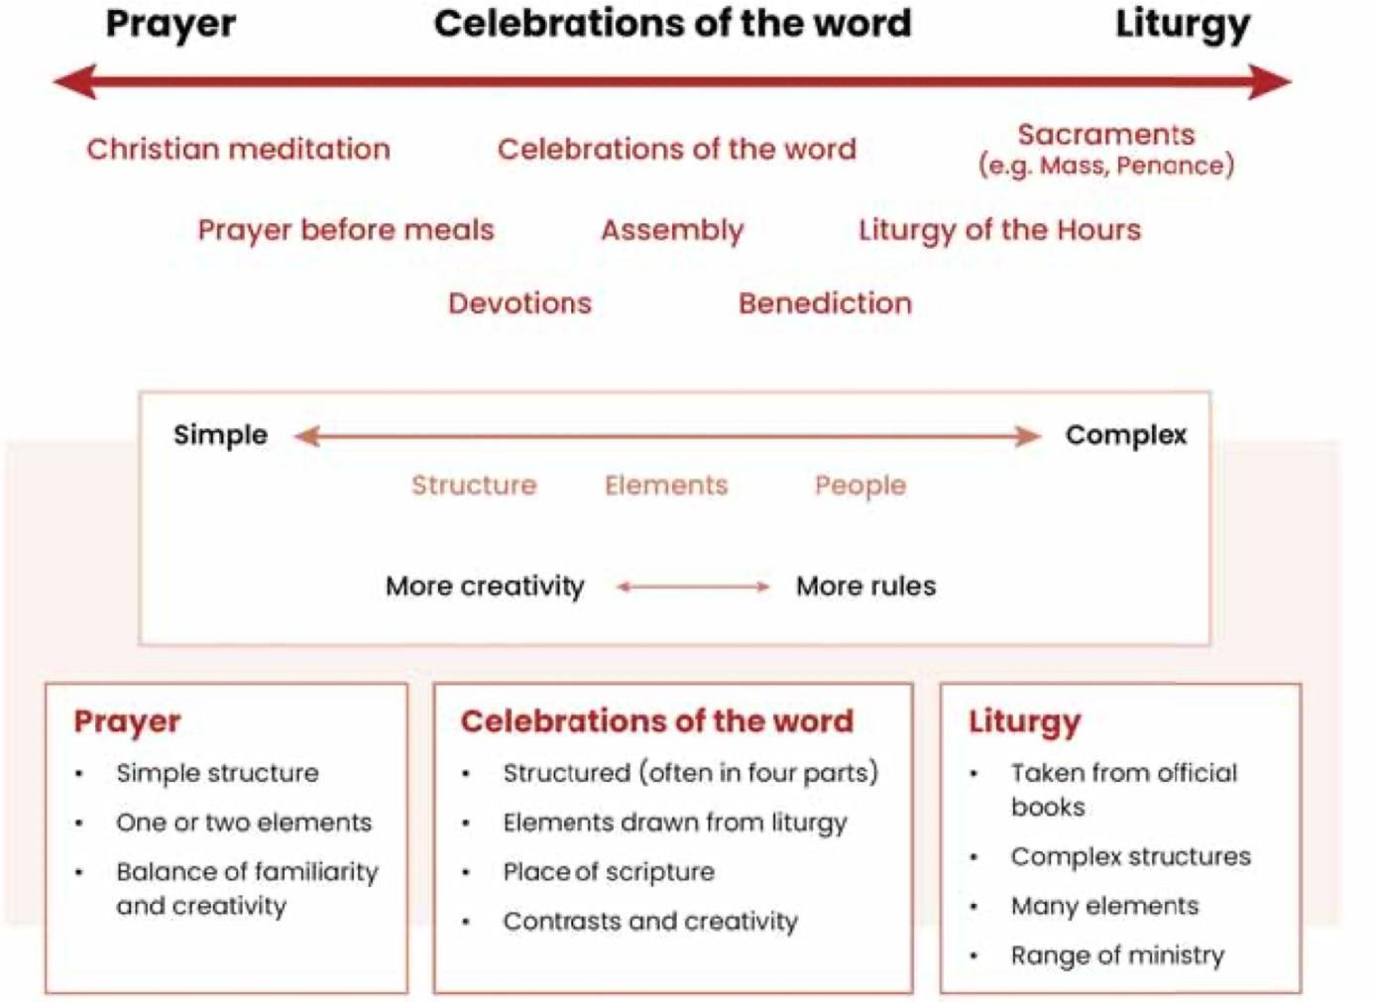
The prayer and liturgy that takes place at St Clare’s forms part of the life of prayer and liturgy of the whole Church, but celebrated in a manner that is appropriate for the distinct educational setting of a school. It is not an alternative to, nor can it replace, the prayer and liturgy celebrated in the local parishes.
Christian worship in St Clare's Catholic Primary school is an integral part of our school life and our worship will be directed at responding to God as present in all aspects of life. It is our loving response in word and action to God's invitation to enter into a relationship with him, made possible through the work of Jesus and the Holy Spirit.

Each day there is an opportunity for collective worship, whether it is class-based, key stage gathering or the whole school coming together. When this takes place in class, a specific "Thought for the day" is highlighted - these may be feast days, aspects in the news or something pertinent to the class, friendship, loneliness etc. Each class has a Prayer Box and daily intentions are taken from the box. The intentions are written by pupils themselves.
The Headteacher/Deputy Headteacher has the main role and responsibility for the Collective Worship; however the RE Co-ordinator works closely with them offering support. This policy is monitored by the RE Co-ordinator and is evaluated and reviewed by the whole school staff and governors every two years, or when it is deemed as necessary. The Curriculum Governors in particular will play the most important role.

MISSION STATEMENT
With Jesus we learn to love, and love to learn.
St Clare's is a welcoming and nurturing Catholic school, where we aim to help every child fulfil their full potential as Children of God. Through every layer of our teaching and learning we believe in fostering a strong sense of belonging and care for one another as part of God's wider family, including the parish and the local community. Always striving for excellence, our children are encouraged to build upon their understanding of the Catholic faith and shine in the love God has for us

Responsibilities:

THE ROLE OF GOVERNORS
Consequently, it is the duty of governors of Catholic schools and colleges, and directors of academies, to direct the promotion, monitoring, and evaluation of prayer and liturgy through the following:
- Agreeing a specific prayer and liturgy policy which reflects the Catholic life and mission of the school.
School responsibilities in facilitating prayer and liturgy:

- Undertaking the periodic review of the policy and implementing any necessary amendments.
- Developing a knowledge and understanding of how prayer and liturgy are underpinned by the liturgical year.
- Understanding the different levels and skills of participation that are reflective of the age and capacity of pupils, and ensuring a strategy is in place for building up these skills of participation as pupils progress through the school.
- Establishing that daily prayer and liturgy is provided for all staff and pupils.
- Participating in the school’s prayer and liturgy, where this is practical.
- Ensuring there is professional development of all staff that focuses on liturgical formation
- and, for relevant staff, planning of prayer and liturgy.
- Overseeing the process for reviewing and reflecting, ensuring the voice of pupils is heard.
- Allocating sufficient financial budgeting.

School leaders
The headteacher is ultimately responsible for the implementation of the prayer and liturgy policy agreed by the governing body or academy board. This is done by having oversight of prayer and liturgy in the school, and ensuring it is understood as central to the school’s unique mission and is included in its development plan. They will do this in collaboration with other staff members,
who may include a designated Prayer and Liturgy Coordinator, as well as other members of the Religious Education team and/or senior leadership team. As a highly visible group within the school, it is important that the leadership team models good practice as they participate in and lead prayer and liturgy.

Prayer and Liturgy Coordinator
The Prayer and Liturgy Coordinator ensures that prayer and liturgy is planned, led, monitored, and evaluated, providing relevant support and resources for staff and pupils where required. They will be responsible for the development of the Annual Plan of Provision. Coordinators will be expected to have a good working knowledge of this Directory and base their practice upon it. They need to ensure that they keep updated with best practice and ongoing formation through contact with diocesan advisers and others. These coordinators may already have a key role in the school, such as chaplain, subject leader for Religious Education, or headteacher.

Prayer with staff
St Clare’s Catholic Primary school offers opportunities for prayer and liturgy not only to pupils, but to staff and governors as well. Praying and celebrating liturgies together on a regular basis offer staff an opportunity to deepen their own spiritual lives and experience different types of prayer. Under the guidance of the Prayer and Liturgy Coordinator, they can also model good practice.

Relationship with parents and carers
The Prayer and Liturgy Coordinator, along with other staff, will seek to keep parents and carers informed about the prayer and liturgical life of the school, including key events. Through the school website, or other media (Dojos, Scopay), we can provide resources to help parents and carers to make links at home with prayer and liturgy and so help to build up the Domestic Church.

Overview of P&L provision
St Clare’s Catholic Primary School provides a comprehensive and deeply rooted programme of prayer and liturgy that reflects the rhythms of the liturgical year, promotes Catholic values, and nurtures the spiritual development of pupils, staff, and the wider school community. The provision is thoughtfully planned and includes a rich variety of opportunities for worship, celebration, and reflection, carefully aligned with the Church’s calendar and the monthly intentions of the Pope.
Each month at St Clare’s is dedicated to a specific theme or devotion, such as the Holy Cross and Our Lady of Sorrows in September, the Holy Rosary in October, and the Holy Family in February. These themes are introduced through assemblies, class worship, and special liturgies, helping pupils to understand and engage with the deeper meaning of the Church’s traditions and teachings. The Pope’s monthly prayer intentions are also incorporated, connecting the school community with the global Church and encouraging awareness of contemporary social and moral issues—for example, prayers for peace and human fraternity, children with incurable diseases, and respect for all human life.
Prayer and liturgy are woven into daily school life. Children participate in classroom prayer four times a day—morning, before and after lunch, and at the end of the day—ensuring a constant spiritual presence throughout their routine. Weekly opportunities for communal worship include class-based collective worship every Friday, a Bible assembly on Thursdays, a Gospel values assembly on Wednesdays, and a Headteacher’s Gospel assembly on Mondays. In addition, hymn practices are held every Tuesday, reinforcing liturgical music as a form of prayer and praise.
The liturgical calendar is observed with reverence and celebration through a series of whole-school Masses and key feast day events. For example, the Feast of St Francis of Assisi and All Saints Day are marked with Mass and liturgies of the Word. During Advent and Lent, special services such as penitential services, the Stations of the Cross (led by Year 6), and reflections support the children's preparation for Christmas and Easter. The school also holds dedicated assemblies and processions for Marian feasts, such as the Feast of Our Lady of Sorrows, the Feast of Our Lady of Walsingham, and the May procession and coronation of the statue of Mary.
Pupils are actively involved in leading aspects of worship, which fosters a sense of ownership and engagement in their spiritual development, for instance, leading the Epiphany liturgy of the Word, and the Stations of the Cross. This involvement supports their confidence and deepens their understanding of the liturgical seasons.
Staff at St Clare’s are also supported in their spiritual journey. Weekly staff meeting prayers, half-termly staff liturgies, termly liturgical formation sessions, and a yearly staff retreat provide spaces for reflection and spiritual nourishment. These practices reinforce the Catholic identity of the school and ensure that staff are equipped to lead and model faith in their roles.
The school also responds to broader Catholic social teaching through engagement in national initiatives such as CAFOD assemblies and Family Fast Days, where food collections are organised to support those in need. These activities link prayer with action, encouraging pupils to live out their faith through compassion and service.
In summary, St Clare’s Catholic Primary School offers a vibrant and holistic prayer and liturgy provision that supports the faith formation of its entire community. Rooted in Catholic tradition and enriched by active participation, regular worship, and a strong connection to the Church’s mission, the school fosters a spirit of reverence, service, and joyful celebration throughout the academic year. (see the example yearly overview).

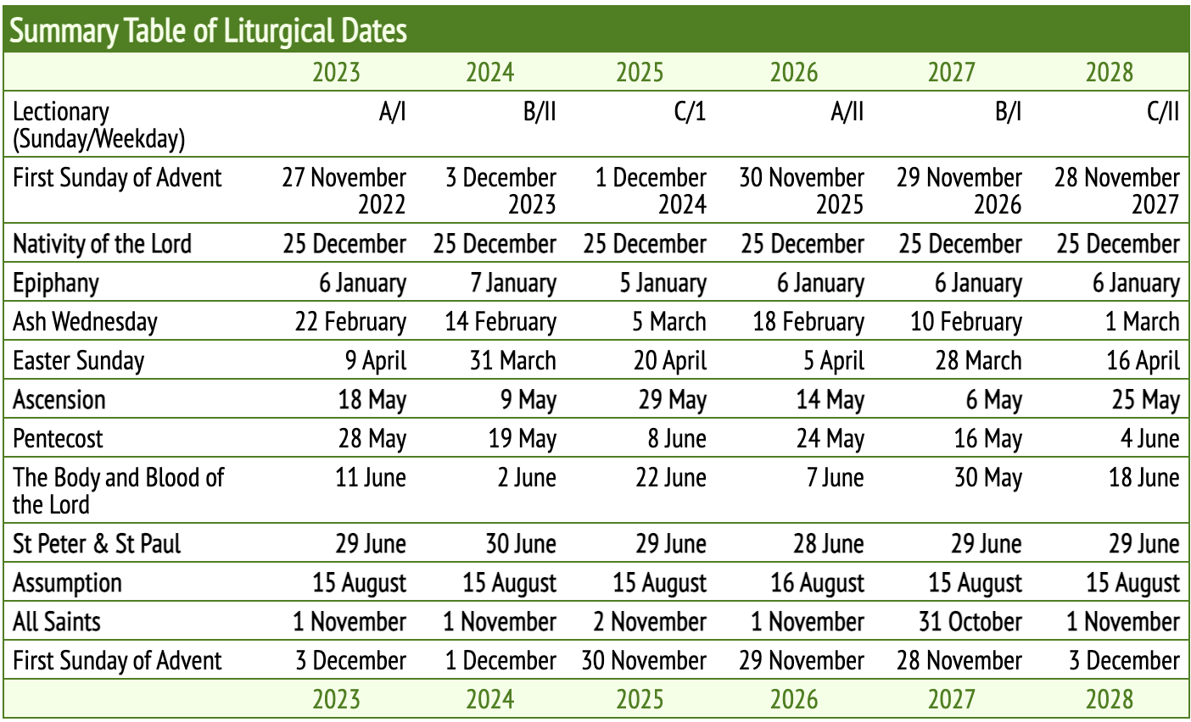

Resourcing
At St Clare’s Catholic Primary School, resourcing for prayer and liturgy is carefully considered to ensure that both staff and pupils are supported in delivering and participating in meaningful worship experiences. Classrooms are equipped with dedicated prayer areas that include age-appropriate religious artefacts, liturgical cloths in the correct colours for each season, candles, crucifixes, Bibles, and other relevant visual aids to help create a sacred and reflective environment. The school provides high-quality resources for collective worship, including scripture readings, prayer books, liturgical planning materials, and music for hymn practice. Staff are given access to planning templates and training to help them prepare and lead class-based worship confidently and in line with the liturgical calendar. Central displays and focal points around the school reflect current themes, feast days, and the liturgical season, further enhancing the spiritual atmosphere. The inclusion of CAFOD and Missio resources and links to national Catholic initiatives ensures that pupils are also resourced to understand and respond to global issues through prayer and action. This thoughtful and consistent resourcing supports the school’s mission to provide rich, reverent, and inclusive prayer and liturgical experiences for all.

Monitoring and evaluation
Evaluation and monitoring of prayer and liturgy at St Clare’s Catholic Primary School play a vital role in ensuring that the spiritual life of the school remains meaningful, inclusive, and rooted in Catholic tradition. The school undertakes regular reviews of its liturgical provision to assess the quality, relevance, and impact of collective worship across all key stages. Senior leaders, including the RE lead and headteacher, observe acts of worship and provide constructive feedback to staff, focusing on pupil engagement, appropriateness of content, and adherence to the liturgical calendar. Pupil voice is also an essential part of the evaluation process—children are given opportunities to reflect on and share their experiences of prayer and liturgy, helping staff to adapt and improve provision in response to their spiritual needs. Staff are encouraged to reflect on their own practice, supported by termly liturgical formation sessions and collaborative planning opportunities. By embedding evaluation and monitoring into its spiritual life, St Clare’s ensures that worship remains dynamic, spiritually enriching, and reflective of the needs of the whole school community.
At St Clare’s Catholic Primary School, children are actively involved in evaluating collective worship through a range of age-appropriate and reflective methods. After participating in class-based worship or whole-school liturgies, pupils are encouraged to share their thoughts and feelings using simple evaluation forms tailored to their level of understanding. These forms may include smiley face scales, sentence starters such as “I liked it when…” or “I felt close to God when…”, and space to write or draw their reflections. Older pupils are invited to complete more detailed evaluations, offering feedback on the structure, content, and impact of the worship, as well as suggestions for improvement or future themes. In some classes, children act as Worship Leaders (liturgy Group) and take an active role in gathering feedback from their peers. These evaluations are reviewed by staff to inform future planning and ensure that worship remains meaningful, inclusive, and responsive to the spiritual development of the children. This approach empowers pupils to take ownership of their faith journey and reinforces the importance of their voice in shaping the school’s prayer life.

Timetable of the Acts of Collective Worship
Monday 9:30

Tuesday 14:50

Wednesday 14:55

Thursday

Friday
Morning

Afternoon

ASSEMBLIES
Whole school assembly led by the Headteacher Focus: Sunday's Gospel.

Singing assembly, hymn practice whole school

Whole School assembly- Gospel values assembly, Catholic Social Teaching

Bible Assembly,
Stay and Pray

Whole School Celebration Assembly

Class-based Celebration of the Word

Term based productions and services:
Christmas Nativity- EYFS and KS1 Easter Production led by LKS2
Nativity and Carol Service at the church- led by year 5 and UKS2
St Clare’s Prays the Rosary - led by year 5
Stations of the Cross - year 6
Lent and Advent Penitential Services - KS2

EUCHARIST
Eucharistic celebrations in school will highlight the Church's season. There will also be additional school Masses which will celebrate a special occasion and will normally be celebrated with all children, (in certain circumstances- children whose faith development has reached an appropriate stage). The same general principles will apply to planning a Eucharistic celebration as other acts of school worship, therefore opportunities for children to participate will be maximised. The readings are taken from the daily Mass readings provided by Universalis.
Key Stage Masses are also celebrated throughout the term. The theme of the Mass, hymns and readings are led by the children- regardless of age. Parents, family, Governors are invited to celebrate in these Masses.
In the last week of Autumn term, all KS2 children take part in a Carol Service in our parish church.
We believe that children are best introduced to prayer, the Sacraments and particularly the Eucharist in a step-by step-approach.
There is a close link between the Parish and the school. The RE-coordinator has the role of the Catechist in the parish.

PRAYER AND THE USE OF SCRIPTURES
At St Clare's children are encouraged to pray daily and to understand that the prayer is "a surge of the heart; it is a simple look towards heaven; it is a cry of recognition and love, embracing both trial and joy." (St Therese of Lisieux) Children are taught that our prayer is 'A close sharing between friends.' (St Theresa of Avila).

Children say Morning Prayer after registration. Lunchtime Grace is prayed before lunch and a Grace after the meal is said together after lunch. At the end of the day, children say an Afternoon Prayer. Teachers introduce children to the new prayers on termly basis, following the Prayer Progression document which has been amended to be in line with the “To love you more dearly”, Prayer and Liturgy directory.

Class celebration of the Word
Our Class Celebration of the Word gives children the opportunity to actively lead moments of prayer and reflection within the classroom. Working in small groups, pupils plan the four key parts of the celebration: Gather, Word, Response, and Mission. They carefully prepare how they will share the message with their classmates. Once the celebration has been delivered, the children reflect on and evaluate their experience, thinking about what went well and what could be improved. This approach ensures that every child has the opportunity to plan, lead, and evaluate a Celebration of the Word, helping them grow in confidence, faith, and understanding.

In the main foyer, children hang their intentions on an Intention Tree. Colour of the leaves is changed, depending on the liturgical season.
Every class has a prayer focus table, as well as an RE display board for the curriculum work.
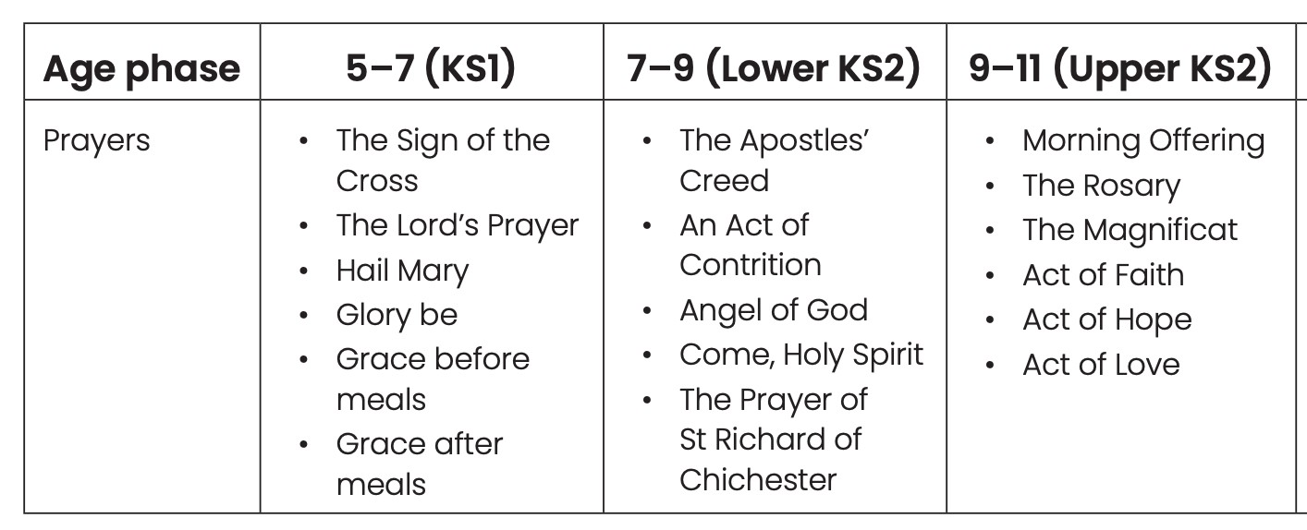
Each class has access to necessary resources, either in their classroom, shared as a phase or on the school network e.g. Come and See books, Church's story, God's Story, Bibles.

Our new Stay and Pray initiative invites parents to join their children on Thursday mornings for a class Celebration of the Word. Each week, a different class takes a turn preparing and leading the celebration, which is thoughtfully planned by the children with the guidance of their class teacher. This special time together encourages reflection, prayer, and a sense of community within our school. Stay and Pray provides a wonderful opportunity for families and staff to come together in faith, reminding us of the words from the Gospel of Matthew: “For where two or three gather in my name, there am I with them.” (Matthew 18:20)

THE PRAYER OF ST RICHARD OF CHICHESTER IS SAID BEFORE EACH RE LESSON.

PRAYER AND LITURGY FORMATION
Participating in prayer and liturgy involves learning a set of actions, ideas, and habits that ideally takes place across the home, school, and parish partnership and over a number of years. This learning is progressive and lifelong. We ensure that formation is provided according to the age and capacity of the children. Because it flows into personal choices and broader habits of discipleship, liturgical formation is not simply a matter of religious education. While it involves engagement with pedagogical content (e.g., learning the structure of the Mass), it also has a catechetical element (responding personally to the word proclaimed and the invitation to Communion).
Liturgical formation has three dimensions, most simply expressed as before, during, and after prayer and liturgy.

Before
Formation before the celebration of prayer and liturgy prepares the pupil to participate. This involves developing their understanding, possibly giving them practical information, and familiarising them with key elements such as chants, responses, and gestures. We hold a special assembly explaining this before each Mass.

After
Reflection is a key follow-up to liturgy, and it is also important to provide an opportunity for the pupils to reflect together on the celebration. Participation in the liturgy is a matter of lifelong learning. Each time we celebrate, we are formed to participate more completely, which in turn forms us to participate more fully in the life and mission of the Church. Children are offered time to reflect on the Scripture read. They are also given opportunity to talk to their peers about it.

Teachers and support staff
All adults, whatever their personal religious affiliation, can contribute to the spiritual life of the school. Each can draw on their unique experience and talents to enhance the preparation and celebration of prayer and liturgy. In their classrooms, adults facilitate prayer and liturgy for pupils, teaching them how to participate meaningfully in different forms of these in order to grow in faith. They provide formation for pupils to plan, lead, and evaluate prayer in a variety of contexts, and collaborate with other professionals to ensure that this is in line with best practice.
In the celebration of Mass, staff form part of the one ‘liturgical assembly’ with pupils, and by their participation, manifested through their body language and response, they go beyond roles of discipline and supervision in providing a model for pupils.
Pupil leadership
Pupils of various ages and abilities take an active role in planning and leading prayer and liturgy in a meaningful and age-appropriate way throughout the school.

Prayer with staff
A Catholic school will offer opportunities for prayer and liturgy not only to pupils, but to staff and governors as well. Praying and celebrating liturgies together on a regular basis offer staff an opportunity to deepen their own spiritual lives and experience different types of prayer. Under the guidance of the Prayer and Liturgy Coordinator, they can also model good practice.
Prayer, liturgy, and inclusion
In St Clare’s Catholic school, all corporate prayer and liturgy will be celebrated from within the Catholic tradition, but this does not mean that the fruits of the celebration are limited only to Catholic pupils and staff. Times of prayer can provide a space for all to reflect on their spiritual journey, be nourished by what they see and hear, and be encouraged to live lives in the service of others.
The liturgical year
The annual cycle of the Church’s liturgical year is centred on Christ and on how he has made salvation possible for us. The year is, then, a sequence of seasons which brings into focus the various aspects of the one mystery of salvation in Christ, who is present in his Church. Children at St Clare’s are taught explicitly about the different seasons of Liturgical year and the colours associated with them.
APPENDIX 1
SUMMARY OF PRAYER AND LITURGY PROVISION

Overview of Prayer and Liturgy provision
Monday | Tuesday | Wednesday | Thursday | Friday
Morning Prayer in class  N – Y6 | Morning Prayer in class  N – Y6 | Morning Prayer in class  N – Y6 | Morning Prayer in class  N – Y6 | Morning Prayer in class  N – Y6
Celebration of the Word: Whole school  Led by HT/DHT  Focus: Sunday’s Gospel |  | Celebration of the Word: KS2 Pupil led  Focus: Liturgical year | EYFS, KS1, KS2  In class prayer  Focus: PPD/Liturgical year | Celebration assembly  Whole school
 | SINGING ASSEMBLY- HYMN PRACTICE- WHOLE SCHOOL  R-Y6 | Celebration of the Word  Pupil led  Focus: GOSPEL VALUES  R-Y6 | KEY STAGE BIBLE ASSEMBLY  R-Y6 | CLASS-LED CELEBRATION OF THE WORD  R-Y6
Grace before meals in class  N – Y6 | Grace before meals in class  N – Y6 | Grace before meals in class  N – Y6 | Grace before meals in class  N – Y6 | Grace before meals in class  N – Y6
Grace after meals in class  N – Y6 | Grace after meals in class  N – Y6 | Grace after meals in class  N – Y6 | Grace after meals in class  N – Y6 | Grace after meals in class  N – Y6
Evening prayer in class  N – Y6 | Evening prayer in class  N – Y6 | Evening prayer in class  N – Y6 | Evening prayer in class  N – Y6 | Evening prayer in class  N – Y6

Mass and Reconciliation
 | N | R | Y1 | Y 1/ 2 | Y2 | Y3 | Y 3/ 4 | Y4 | Y5 | Y6 | GOVERNORS | PARENTS
Whole school Masses
School Feast Day Mass
HOLY DAYS OF OBLIGATION
UKS2 Mass
LKS2 Mass
EYFS AND KS1 MASS
PENITENTIAL SERVICE
CONFESSION

Special Celebrations
 | N | Rec | Y1, y1/ 2 and y2 |  | Y3, y 3/ 4 and Y4 |  | Y5 | Y6 | Parents
EYFS &  KS1 Nativity |  |  |  |  |  |  |  |  | R, Y1&Y2
Nursery Nativity |  |  |  |  |  |  |  |  | Nursery
KS2 nativity and carol concert |  |  |  |  |  |  |  |  | All parents
LKS2 The Easter Story |  |  |  |  |  |  |  |  | Y3, 3/ 4 and y4
Whole school
May Procession
Stations of the cross |  |  |  |  |  |  |  |  | y6 parents
St Clare’s Pray the Holy Rosary  Led by y5 |  |  |  |  |  |  |  |  | Y5 parents
Harvest |  |  |  |  |  |  |  |  | All parents in key stages

Role | Name | Signature | Date
Headteacher
P& L Lead
Chair of Governors
Review Date

APPENDIX 2
EXAMPLE OF THE PROVISION OVERVIEW

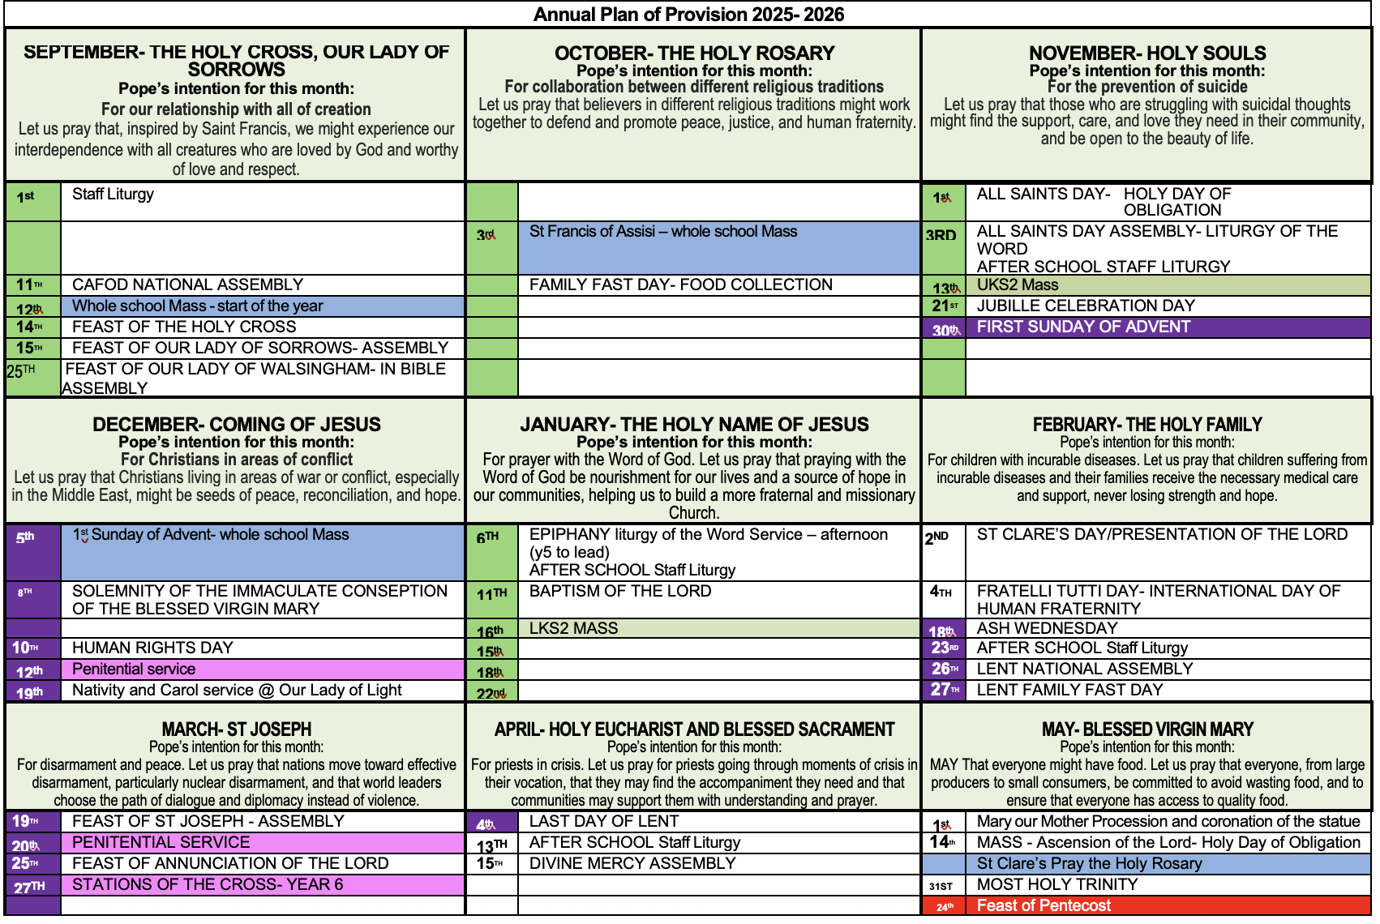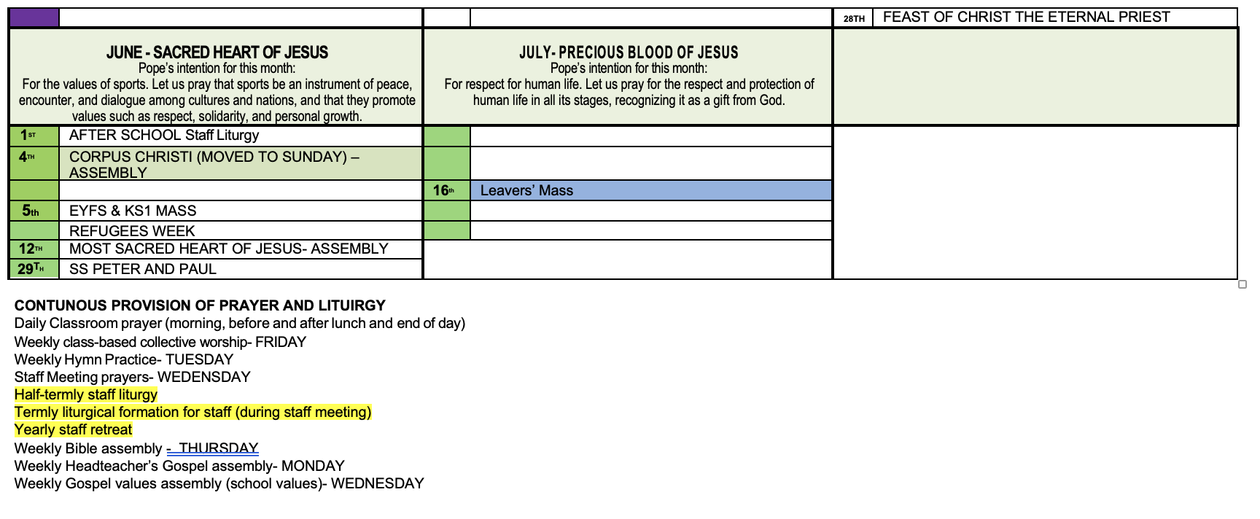

APPENDIX 3
PRAYER PROGRESSION FROM THE NEW P&L DOCUMENT



